Online administrative procedures: identify yourself with digital keys
Completing administrative procedures online is easy. But before you start, you must identify yourself, meaning that you have to confirm your identity electronically via a digital key.
Before starting any administrative procedures online, you must ensure that you have one of the following digital keys.

- eID
The eID is the Belgian electronic identity card. In particular, it allows you to identify yourself so as to prove your identity, your nationality, your age... electronically. Use your eID and a card reader to log in securely to online public services.
Note, an eID is not the same as the special identity card (SIC). Indeed, the SIC does not contain a national number. Refer to the ‘activation process for a digital key via an activation code and link’, to obtain a digital key to complete administrative procedures online with Belgian public administrative services.
- itsme app
Secure and easy to use, itsme® is a mobile digital identity app. It can be installed directly on your smartphone with your identity card or debet card. After installing, itsme® allows you to identify yourself on your computer, tablet or telephone when you want to log in to online public services.
You cannot use eID or itsme®?

- Discover the activation process for a digital key via an activation code and link

To gain access to this alternative digital key, you will require an email address and you will have to go to your nearest registration office.
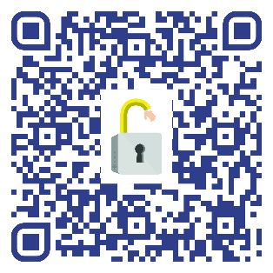
A local registration office?

Many Belgian cities and municipalities act as local registration offices. Consult the list of local registration offices to see which cities and municipalities also act as local registration offices for non-residents by scanning the QR code or go to Requesting and activating digital keys | DG Digital Transformation (bosa.be).

To obtain this digital key, make an appointment with these cities or municipalities' population service.

Obtain a digital key with activation code
Step 1:
Obtain the digital key with activation code?
- Go to the office IN PERSON;
- Take your identity card or passport with you*;
- Have a personal email address
*New arrivals in the process of registering? A BIS number can be created by the local registration office (municipality)
Contact the nearest local registration office and make an appointment. Consult the list of local registration offices to see which cities and municipalities also act as local registration offices for non-residents by scanning the QR code or go to Requesting and activating digital keys | DG Digital Transformation (bosa.be).

Step 2:
When you visit the registration office, your identity will be checked via your identity card or passport.
Step 3:
After identification, you will be issued with a paper containing your activation code and a link will be sent to your personal email address.
- In your personal email, open the message entitled "CSAM – My digital keys: activation";
- click the red button "Activate your digital keys".
Step 4
After opening the activation link, enter the activation code which appears on the paper from the local registration office. After correctly entering the activation code and clicking on "Next", you are able to activate a digital key

Activate a digital key with activation code
It is possible to activate a digital key to receive a security code using a mobile app, via SMS or by email.
We recommend activating the "security code sent by email" digital key as this key is easy to use and secure. You will find all the information you need here to activate this digital key using the following document
Our recommendation? Activate your digital key with "security code sent by email"
After activating your digital key, it remains valid and reusable for life.
To log in, enter your username and password and a unique security code. This code, received by email every time you log in, is only valid for 10 minutes.
Modify the way you receive your unique security code?
It is always possible for you to change the way you receive the unique security code. Go to the page My digital keys - CSAM.be to manage your digital keys.

This information is provided to you by easy.brussels, the agency for administrative simplification in the Brussels-Capital Region in collaboration with the FPS BOSA and the European Commission.
